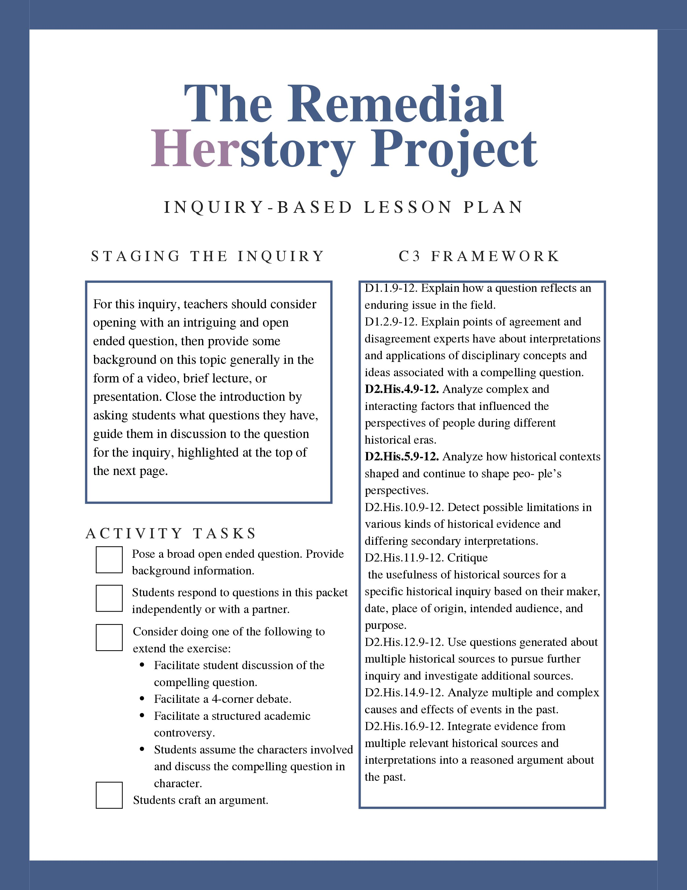

Compelling Question Here
Provide simple student-centered instructions here.

Document A: Title
Paste Text

Full Chicago Style Citation

Document B: Title
Paste Text

Full Chicago Style Citation

Questions for Analysis

