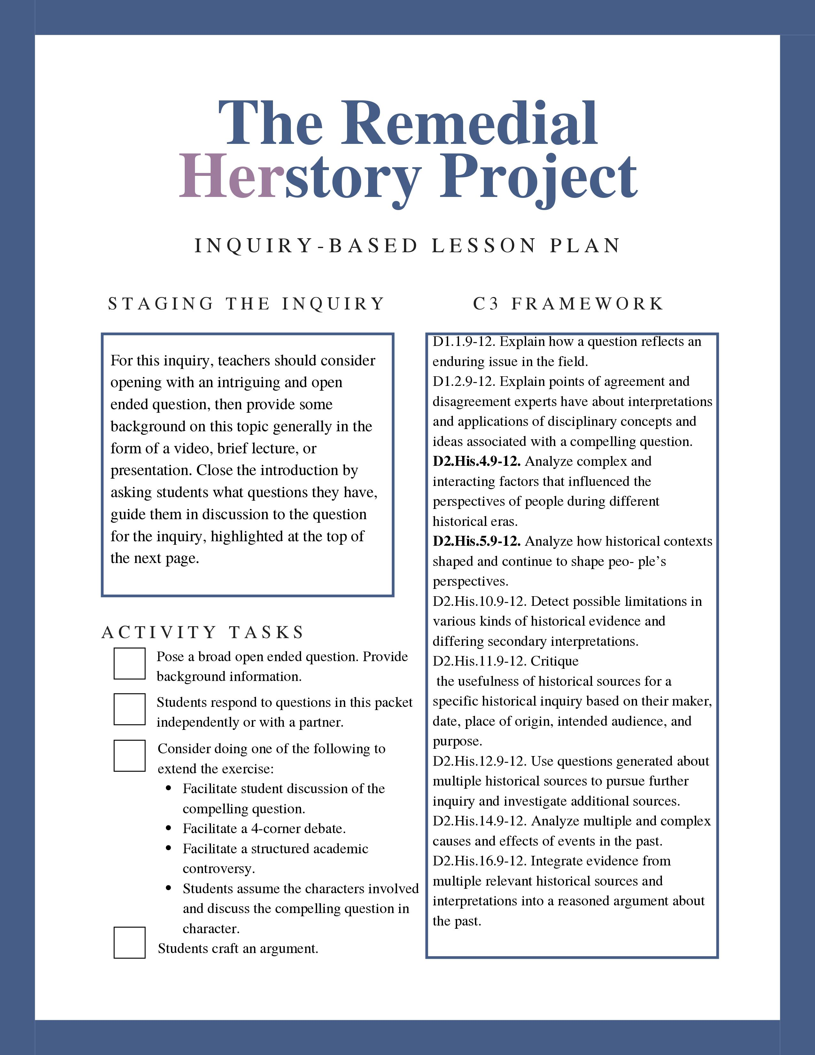

Compelling Question Here
Provide simple student-centered instructions here.

Inquiry
Below are differing documents in favor and against …
- As you read, record sentences or ideas that show…
- After you finish the two middle columns, look back at the evidence. Which information is most persuasive to you? Mark that #8. Which evidence is least persuasive to you? Mark that #1.

Rank | Evidence Side A | Evidence Side B | Rank

Questions for Analysis
- Add up the rank on each side. Which side weighed more? Why do you think it worked out that way?

- In conclusion, compelling question here?

Document A: Title
Paste Text
Full Chicago Citation

Document B: Title
Paste Text
Full Chicago Citation

Document C: Title
Paste Text
Full Chicago Citation

Document D: Title
Paste Text
Full Chicago Citation

