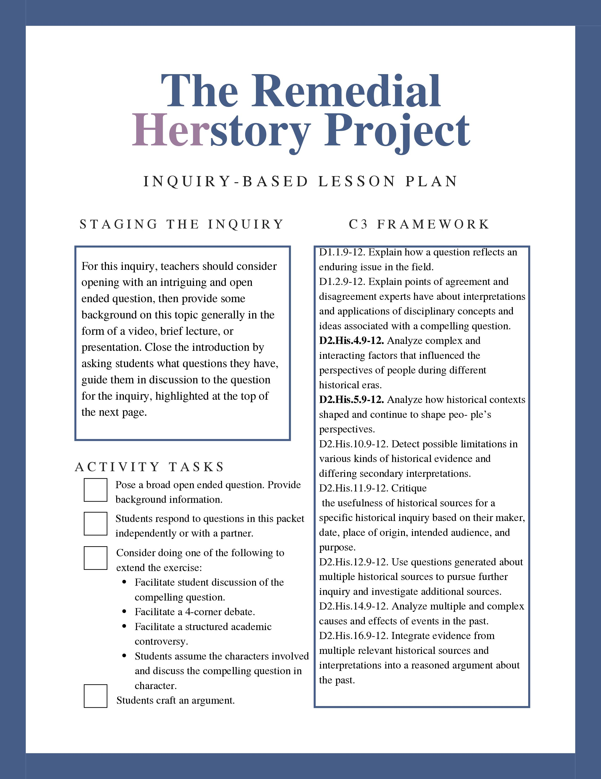

Compelling Question Here
Provide simple student-centered instructions here.

Document A: Title this document should be a myth, or an outdated theory
Paste Text

Full Chicago Style Citation

Hypothesis 1: Based on this document, Compelling Question Here

Document B: Title
Paste Text

Full Chicago Style Citation

Document C: Title
Paste Text

Full Chicago Style Citation

Hypothesis 2: Based on these documents, Compelling Question Here

Document D: Title
Paste Text

Full Chicago Style Citation

Document E: Title
Paste Text

Full Chicago Style Citation

Hypothesis 3: Based on these documents, Compelling Question Here

Questions for Analysis

