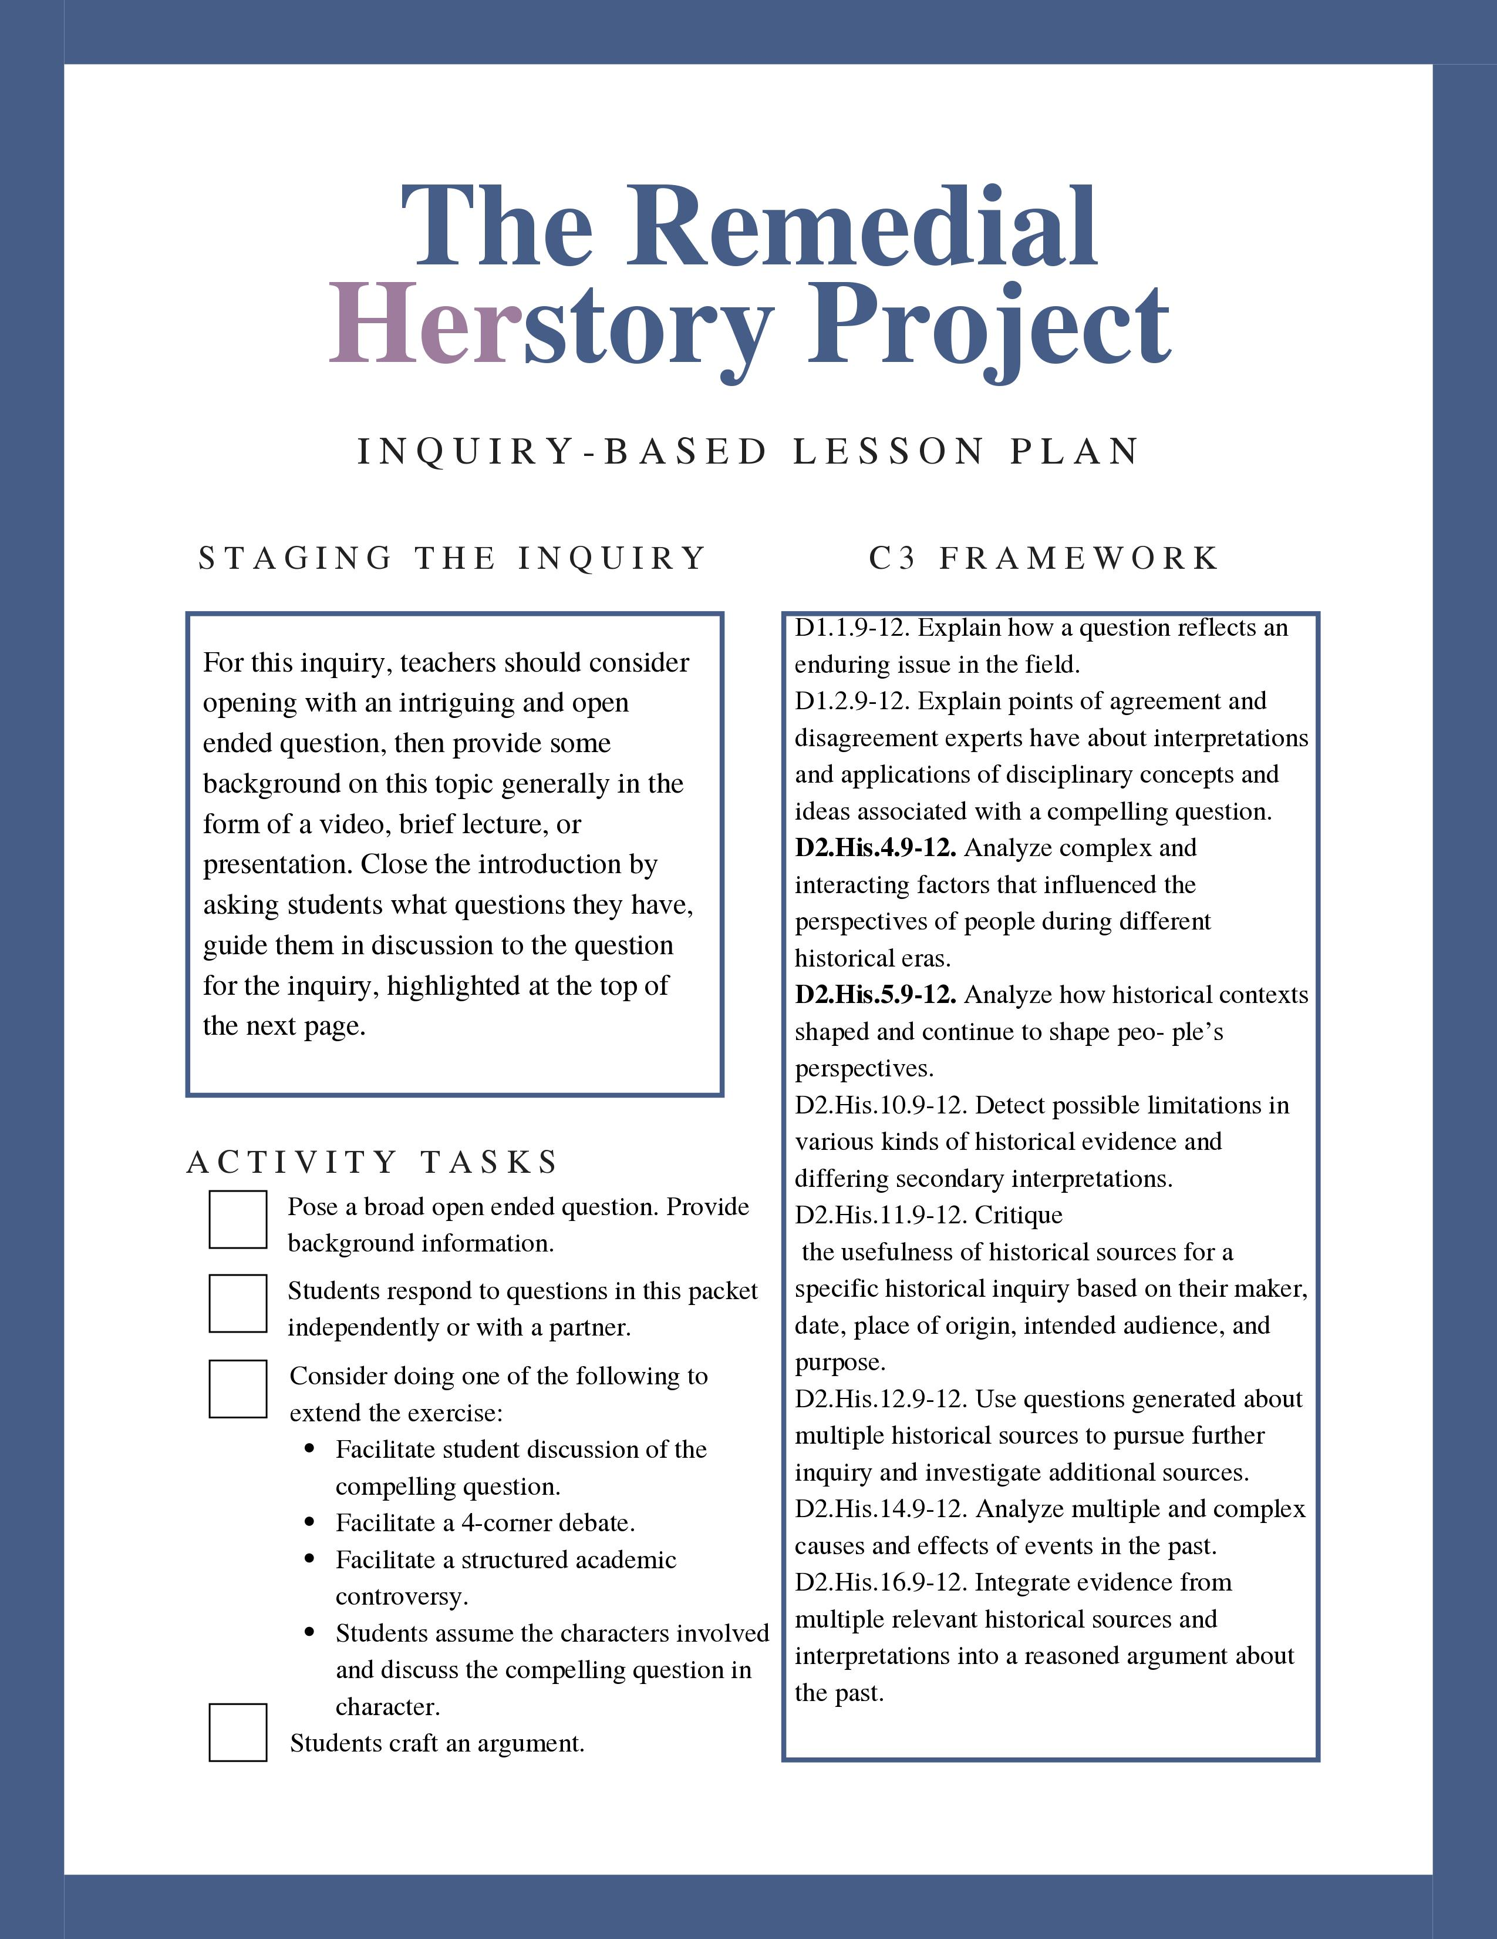

Compelling Question Here
Provide simple student-centered instructions here.

 | Document A | Document B | Document C
What are the differences between these documents?
What similarities exist between these documents?
Additional Question
Additional Question

Document A: Title
Paste Text
Full Chicago Citation

Document B: Title
Paste Text
Full Chicago Citation

Document C: Title
Paste Text
Full Chicago Citation

